Good News from our CLE Team

The Clinical Legal Education (CLE) Team is happy to share that in January 2021 the CFA (Court of Final Appeal) allowed the appeal of our CLE’s client in HKSAR v Lo Kin Sun [2021] HKCFA 1 on the substantial and grave injustice ground, with Mr Eric Cheung and junior counsel Mr Carter Chim appearing for the client on a pro bono basis. This is the 7th successful case which we have assisted in rectifying a miscarriage of justice at the CFA level since the launch of the CLE Programme in January 2010.

In this case, Mr. Lo, being the proprietor of a small restaurant and a man of clear record, was charged with the offence of common assault against an officer of the Environmental Protection Department. Although the prosecutor and the magistrate had all along persuaded him to have the matter disposed of by way of bind-over with no criminal conviction record, Mr. Lo refused to accept the offer as he persistently denied having assaulted or had any physical contact with the officer. He defended the charge without any legal representation and was convicted by the magistrate after trial. After spending 14 days in prison on remand pending certain sentencing reports, he was eventually sentenced to 4 weeks’ imprisonment but suspended for 18 months.

Through his son, Mr Lo sought free legal advice from us after his conviction and sentence. The CLE Team has decided to arrange for pro bon legal representation to Mr. Lo for his appeal before the Court of First Instance, which was eventually heard and dismissed in October 2018. With our further pro bono assistance, Mr. Lo was granted leave to appeal to the CFA in July 2020 and his appeal was eventually allowed on 4 January 2021 at the hearing last presided by Ma CJ before his retirement.

Media Coverage:
https://bit.ly/31MXODq
https://qrgo.page.link/PpD5V
https://qrgo.page.link/fHZTo

The CLE Programme was launched in January 2010, as the first and only live-client CLE Programme in Hong Kong. It runs a Free Legal Advice Scheme (“FLAS”) on HKU Campus under the Duty Lawyer Service, offering free preliminary legal advice to members of the public having actual legal problems involving the laws of Hong Kong. The Programme is mainly assisted by senior law students who enrol in the one-semester CLE elective course. During the course, students handle real cases under the supervision of teachers (who are also qualified lawyers) and Voluntary Lawyers.

As at December 2020, we have handled more than 2000 cases and around 600 students were involved.

Despite the high operation cost, the Faculty is committed to provide quality experiential learning to students via the CLE Programme, in which students can develop different lawyering skills through handling real cases of different nature, while providing assistance to rectify miscarriage of justice. In September 2019 the CLE Team moved to a new office at G07 Cheng Yu Tung Tower and recruited two additional full-time teaching staff, Ms Patricia Ho and Mr. Carter Chim, with a view to further enhancing our service to the public and quality teaching to our students. Please visit https://www.law.hku.hk/cle/ for details and consider supporting the Programme.

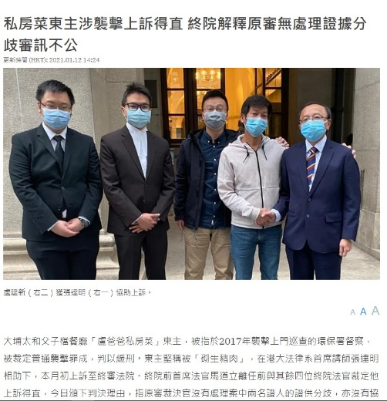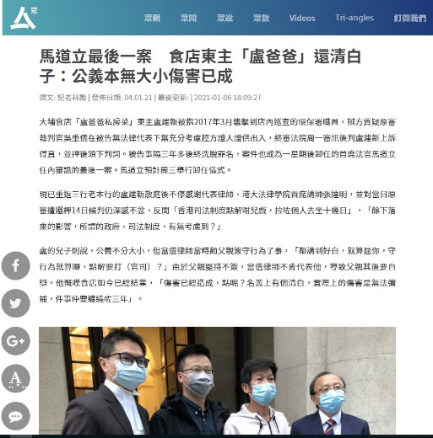

***

Congratulations!

Our heartiest congratulations go to Mr Eric Cheung and Professor Anne Cheung who tied the knot in October 2020. The Faculty wishes the two of them, who are our exceptional friends, colleagues and alumni, a lifetime of love and happiness.

Another round of applause also goes to Eric for the Law Society's 2020 Individual Gold Award and Distinguished Community Service Award, and Patricia for the Distinguished Pro Bono Service Award, which recognize their continuous contribution to the profession and the community.

